NIGERIAN CAPITAL DEVELOPMENT FUND (NCDF GROUP)
Conflicts of Interest Policy
Identification, disclosure, escalation and management of actual, potential and perceived conflicts
Institutional standard policy and framework document prepared for governance, investor diligence, and operational implementation across the NCDF Group ecosystem. This document is structured with reference to international good practice used by development finance institutions, including IFC-style governance, risk, and environmental and social management approaches.
Document owner | NCDF Group Board / Company Secretariat
Applies to | HoldCo, regulated entities, funds, SPVs, programmes and controlled subsidiaries
Review cycle | Annual review or earlier if triggered by material change
Reference architecture | IFC-style governance and control environment, OECD corporate governance principles, three-lines model, risk-based compliance

Executive summary
Conflicts of Interest Policy establishes the minimum institutional standard for the NCDF Group in this domain. It is written for use by the Board, committees, executives, control functions, programme leaders, regulated entities, fund vehicles and project companies. The design intent is to create a governance document that can be used both operationally and in investor / DFI diligence, with clear authority, process, evidence standards and accountability.

Benchmark reference points
Reference point | How it informs NCDF documents
IFC-style governance and ESMS practice | Management-system orientation, risk-based controls, escalation and action planning.
G20/OECD corporate governance principles | Board stewardship, disclosure quality, shareholder rights and committee discipline.
Three lines model | Clear separation of ownership, oversight and assurance responsibilities.
Risk-based financial crime practice | Enhanced due diligence, sanctions screening, beneficial ownership review and suspicious activity escalation.

Framework diagram
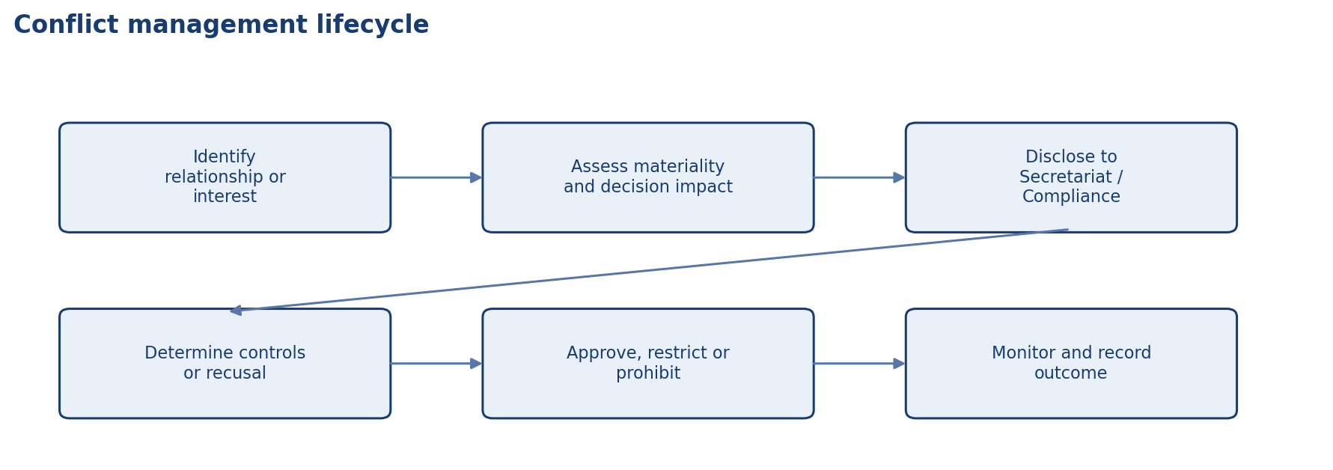
Conflict management lifecycle

Scope and application
Unless expressly excluded in writing, this document applies to NCDF Holdings Limited, controlled subsidiaries, regulated entities, managed funds, project SPVs, corporate functions, country or state programmes, and staff or contractors acting on behalf of the Group. Where a fund constitution, shareholder agreement, regulatory licence or concession agreement imposes an additional requirement, management shall reconcile the difference in favour of the stricter or more specific control.

Authority and approval
This document is issued under the authority of the NCDF Group Board and, where applicable, applies through delegated authority to the Board committees, management committees, regulated entities, fund vehicles, special purpose vehicles and controlled subsidiaries. Where local law, fund documentation or regulatory licence conditions impose stricter requirements, the stricter standard prevails.

Definitions and interpretive principles
For the purposes of this document, 'Board' means the board of the relevant NCDF entity; 'Group' means NCDF Holdings Limited together with controlled entities, programmes and managed vehicles; 'material' means any matter that could reasonably influence an investor, regulator, counterparty or stakeholder decision; and 'three lines' refers to business ownership of risk, independent oversight, and independent assurance.

Policy objective
This policy sets out how NCDF identifies, discloses, assesses, manages and records actual, potential and perceived conflicts of interest. It is designed for an institutional platform in which the same ecosystem may contain shareholders, directors, employees, fund managers, advisors, co-investors, SPVs, public counterparties and beneficiaries whose interests may intersect.
• Provide a clear decision and control architecture that can withstand Board, auditor, regulator and investor scrutiny.
• Create consistent expectations across HoldCo, regulated entities, funds, SPVs and programmes.
• Reduce ambiguity, control bypass and key-person dependency through documented process and accountability.

Scope of conflicts
Conflicts may arise from personal financial interests, family relationships, close personal relationships, outside employment, fiduciary duties to other entities, political exposure, gifts and hospitality, procurement participation, related-party transactions, co-investment, proprietary information, fundraising arrangements, advisory mandates and use of corporate opportunities. Perceived conflicts matter even if no improper conduct occurs, because they can undermine trust and legitimacy.

Disclosure obligations
Directors, committee members, officers and designated employees shall make prompt and complete written disclosures of relevant interests at appointment, annually thereafter and whenever circumstances change. Meeting agendas shall include a standing conflict declaration item. Declarations shall be specific enough to permit informed judgement regarding recusal, restricted access, independent review or prohibition.

Assessment and response
Conflicts shall be assessed considering materiality, influence over decision-making, proximity to sensitive information, whether the matter concerns public money or regulated activities, and whether an informed third party would perceive compromised objectivity. Management responses may include disclosure only, enhanced monitoring, abstention from discussion, formal recusal from decision, transfer of responsibility, independent valuation, ring-fencing of information, divestment or prohibition.

Registers and documentation
The Company Secretary or Compliance function shall maintain a central conflicts register, related-party register and meeting-specific recusals log. Decisions regarding conflict treatment shall be documented clearly and retained with the relevant board, committee, investment or procurement records.

Special rules for investment and procurement
Any person with a conflict in relation to an investment proposal, tender, advisory assignment, valuation, or capital raise shall not influence scoping, selection, negotiation, diligence, recommendation or approval unless expressly authorised with documented safeguards. Related-party transactions require heightened review, arm’s-length validation and approval at the appropriate governance level.

Culture and enforcement
Failure to disclose or properly manage conflicts is a conduct breach and may trigger disciplinary action, removal from role, invalidation of decision processes, contract termination or escalation to regulators or law-enforcement agencies where required.

Roles and responsibilities

Responsibility matrix
Control point | Expectation
Annual declarations | All directors, executives and designated staff file disclosures.
Meeting declarations | Standing agenda item at each Board and committee meeting.
Registers | Central conflicts register and related-party register maintained.
Restricted access | Applied where conflict does not require full recusal but limits information rights.
Escalation | Material conflicts escalated to Chair, Secretariat, Compliance or Board.

Operating protocol
The following minimum operating protocol shall apply unless a stricter procedure is approved for the relevant entity or transaction type.
• Use approved templates, registers and agenda structures so decisions are comparable over time and across entities.
• Maintain documented evidence of review, challenge, concurrence, approval and implementation tracking.
• Escalate exceptions, overdue actions, threshold breaches and material incidents promptly to the designated authority.
• Retain records in a controlled repository with version history, ownership and access controls.
• Provide periodic attestation or reporting to the Board or relevant committee on implementation effectiveness.

Minimum recurring deliverables
Deliverable | Typical owner | Frequency | Primary audience
Policy / charter review | Policy owner + Company Secretary | Annual | Board or committee
Management information pack | Relevant executive / control function | Quarterly | Board / committee / management forum
Training and awareness evidence | Compliance / Risk / Secretariat / HR | Annual | Board committee and internal audit
Exception and remediation log | Process owner | Monthly / quarterly | Executive management and relevant committee
Independent assurance activity | Internal Audit / external specialist | Risk-based plan | Audit & Risk Committee / Board

Implementation, review and records
Management shall maintain procedures, templates, registers and evidence necessary to implement this document in a manner capable of external review. The Company Secretary or designated policy owner shall maintain the approved master copy, revision history, approval minute references, and distribution controls for all controlled versions.

Minimum governance artefacts
Artefact | Owner | Minimum frequency | Evidence
Board or committee workplan | Company Secretary / Chair | Annual | Approved calendar and agenda pack
Policy attestation or acknowledgement | People & Culture / Compliance | Annual | Signed attestations or system logs
Training and awareness | Compliance / Risk / Secretariat | At onboarding and annually | Attendance logs and materials
Exception register | Policy owner | As needed | Documented waivers and remediation actions
Board reporting | Relevant executive owner | Quarterly | Board / committee papers

Appendix: document control summary

Control sheet
Field | Entry
Document status | Institutional policy / charter / framework
Primary audience | Board, management, regulated entities, fund governance teams and diligence stakeholders
Review trigger events | Regulatory change, major transaction, operating model change, control failure, external assurance finding or Board instruction
Related documents | Code of business conduct and ethics, disclosure policy, delegated authorities, risk governance, committee charters, ESMS, AML/KYC, procurement and compliance procedures
Retention expectation | Retain current and superseded versions in controlled corporate records repository

