NIGERIAN CAPITAL DEVELOPMENT FUND (NCDF GROUP)
Delegation of Authority Manual
Decision rights, approval thresholds, escalation rules and control discipline across the NCDF ecosystem
Institutional standard policy and framework document prepared for governance, investor diligence, and operational implementation across the NCDF Group ecosystem. This document is structured with reference to international good practice used by development finance institutions, including IFC-style governance, risk, and environmental and social management approaches.
Document owner | NCDF Group Board / Company Secretariat
Applies to | HoldCo, regulated entities, funds, SPVs, programmes and controlled subsidiaries
Review cycle | Annual review or earlier if triggered by material change
Reference architecture | IFC-style governance and control environment, OECD corporate governance principles, three-lines model, risk-based compliance

Executive summary
Delegation of Authority Manual establishes the minimum institutional standard for the NCDF Group in this domain. It is written for use by the Board, committees, executives, control functions, programme leaders, regulated entities, fund vehicles and project companies. The design intent is to create a governance document that can be used both operationally and in investor / DFI diligence, with clear authority, process, evidence standards and accountability.

Benchmark reference points
Reference point | How it informs NCDF documents
IFC-style governance and ESMS practice | Management-system orientation, risk-based controls, escalation and action planning.
G20/OECD corporate governance principles | Board stewardship, disclosure quality, shareholder rights and committee discipline.
Three lines model | Clear separation of ownership, oversight and assurance responsibilities.
Risk-based financial crime practice | Enhanced due diligence, sanctions screening, beneficial ownership review and suspicious activity escalation.

Framework diagram
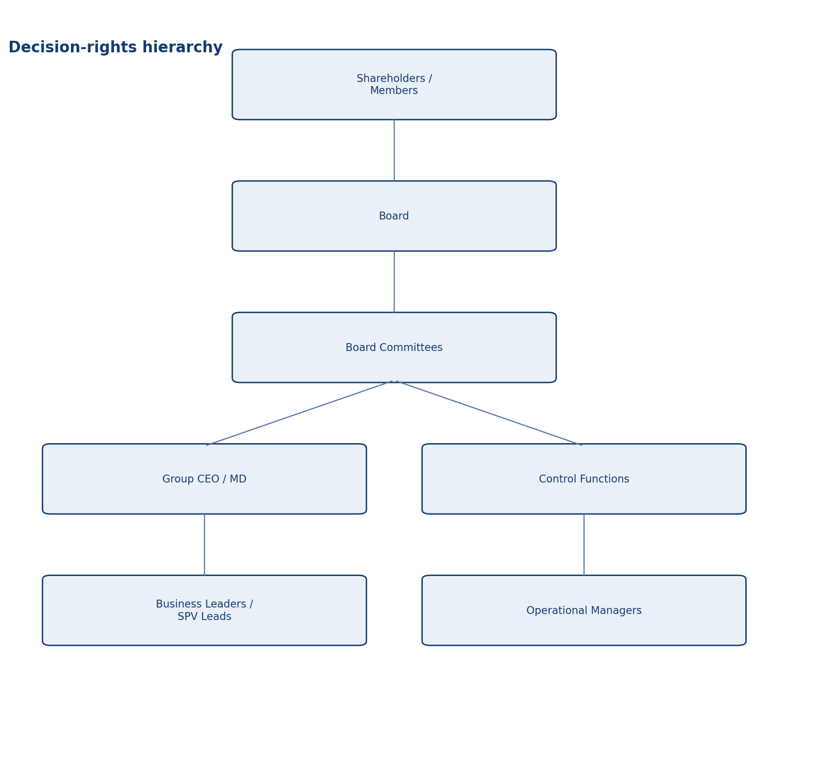
Decision-rights hierarchy

Scope and application
Unless expressly excluded in writing, this document applies to NCDF Holdings Limited, controlled subsidiaries, regulated entities, managed funds, project SPVs, corporate functions, country or state programmes, and staff or contractors acting on behalf of the Group. Where a fund constitution, shareholder agreement, regulatory licence or concession agreement imposes an additional requirement, management shall reconcile the difference in favour of the stricter or more specific control.

Authority and approval
This document is issued under the authority of the NCDF Group Board and, where applicable, applies through delegated authority to the Board committees, management committees, regulated entities, fund vehicles, special purpose vehicles and controlled subsidiaries. Where local law, fund documentation or regulatory licence conditions impose stricter requirements, the stricter standard prevails.

Definitions and interpretive principles
For the purposes of this document, 'Board' means the board of the relevant NCDF entity; 'Group' means NCDF Holdings Limited together with controlled entities, programmes and managed vehicles; 'material' means any matter that could reasonably influence an investor, regulator, counterparty or stakeholder decision; and 'three lines' refers to business ownership of risk, independent oversight, and independent assurance.

Purpose
The Delegation of Authority Manual (DoA) translates Board oversight into a disciplined operating model by assigning clear decision rights, approval thresholds and escalation rules for financial commitments, contracts, procurement, hiring, capital deployment, treasury activity, public disclosures, litigation and policy exceptions. The DoA is a core anti-error and anti-fraud control.
• Provide a clear decision and control architecture that can withstand Board, auditor, regulator and investor scrutiny.
• Create consistent expectations across HoldCo, regulated entities, funds, SPVs and programmes.
• Reduce ambiguity, control bypass and key-person dependency through documented process and accountability.

Principles of delegation
Authority follows accountability and competence; no person may approve a transaction that creates a personal benefit without independent review; delegated authority cannot be exercised where a conflict exists; decisions must be supported by adequate documentation; the maker-checker principle applies to financially significant transactions; and authority may be reduced or withdrawn where control quality or performance is inadequate.

Reserved versus delegated matters
The Manual distinguishes Board-reserved matters, committee authorities, chief executive delegated powers, control-function veto or concurrence rights, and sub-delegations to business or programme leaders. Any ambiguity is resolved conservatively, with escalation upward rather than assumed authority.

Threshold architecture
Thresholds should be calibrated by transaction type, risk and legal significance rather than by a single monetary limit. Separate schedules should exist for operating expenditure, capital expenditure, procurement commitments, contract execution, settlements, hiring and remuneration, credit or investment approvals, treasury placements, write-offs and policy waivers. Aggregation and anti-avoidance rules apply so that transactions may not be split to circumvent approval thresholds.

Evidence and workflow
Every approval should identify: the decision requested; legal entity; amount and currency; budget source; strategic rationale; risk and compliance review; procurement route where relevant; supporting diligence; and execution conditions. Digital workflow tools or controlled approval memos should preserve time-stamped evidence and support later audit.

Emergency authority
An emergency authority route may be used only where delay would materially prejudice the entity or public safety, and where normal escalation is impracticable. Any emergency approval must be documented, narrowly scoped and ratified at the next appropriate governance meeting.

Periodic review
The DoA shall be reviewed at least annually and whenever there is a restructuring, new regulated activity, new fund launch, material control failure, significant growth in asset base or changes in risk appetite.

Roles and responsibilities

Responsibility matrix
Decision layer | Examples
Board reserved | Strategy, major M&A, new vehicles, core policies, material financing.
Committee delegated | Audit/risk oversight, investment approvals within charter, governance nominations.
CEO / MD | Execution of strategy, approved budget deployment within threshold, hiring within mandate.
Control concurrence | Risk, legal, compliance, finance or ESG sign-off where specified.
Operational managers | Routine approvals within threshold and documented workflow.

Operating protocol
The following minimum operating protocol shall apply unless a stricter procedure is approved for the relevant entity or transaction type.
• Use approved templates, registers and agenda structures so decisions are comparable over time and across entities.
• Maintain documented evidence of review, challenge, concurrence, approval and implementation tracking.
• Escalate exceptions, overdue actions, threshold breaches and material incidents promptly to the designated authority.
• Retain records in a controlled repository with version history, ownership and access controls.
• Provide periodic attestation or reporting to the Board or relevant committee on implementation effectiveness.

Minimum recurring deliverables
Deliverable | Typical owner | Frequency | Primary audience
Policy / charter review | Policy owner + Company Secretary | Annual | Board or committee
Management information pack | Relevant executive / control function | Quarterly | Board / committee / management forum
Training and awareness evidence | Compliance / Risk / Secretariat / HR | Annual | Board committee and internal audit
Exception and remediation log | Process owner | Monthly / quarterly | Executive management and relevant committee
Independent assurance activity | Internal Audit / external specialist | Risk-based plan | Audit & Risk Committee / Board

Implementation, review and records
Management shall maintain procedures, templates, registers and evidence necessary to implement this document in a manner capable of external review. The Company Secretary or designated policy owner shall maintain the approved master copy, revision history, approval minute references, and distribution controls for all controlled versions.

Minimum governance artefacts
Artefact | Owner | Minimum frequency | Evidence
Board or committee workplan | Company Secretary / Chair | Annual | Approved calendar and agenda pack
Policy attestation or acknowledgement | People & Culture / Compliance | Annual | Signed attestations or system logs
Training and awareness | Compliance / Risk / Secretariat | At onboarding and annually | Attendance logs and materials
Exception register | Policy owner | As needed | Documented waivers and remediation actions
Board reporting | Relevant executive owner | Quarterly | Board / committee papers

Appendix: document control summary

Control sheet
Field | Entry
Document status | Institutional policy / charter / framework
Primary audience | Board, management, regulated entities, fund governance teams and diligence stakeholders
Review trigger events | Regulatory change, major transaction, operating model change, control failure, external assurance finding or Board instruction
Related documents | Code of business conduct and ethics, disclosure policy, delegated authorities, risk governance, committee charters, ESMS, AML/KYC, procurement and compliance procedures
Retention expectation | Retain current and superseded versions in controlled corporate records repository

