NIGERIAN CAPITAL DEVELOPMENT FUND (NCDF GROUP)
Environmental & Social Risk Management System (ESMS)
IFC-style management system for identifying, assessing, managing and monitoring environmental and social risk
Institutional standard policy and framework document prepared for governance, investor diligence, and operational implementation across the NCDF Group ecosystem. This document is structured with reference to international good practice used by development finance institutions, including IFC-style governance, risk, and environmental and social management approaches.
Document owner | NCDF Group Board / Company Secretariat
Applies to | HoldCo, regulated entities, funds, SPVs, programmes and controlled subsidiaries
Review cycle | Annual review or earlier if triggered by material change
Reference architecture | IFC-style governance and control environment, OECD corporate governance principles, three-lines model, risk-based compliance

Executive summary
Environmental & Social Risk Management System (ESMS) establishes the minimum institutional standard for the NCDF Group in this domain. It is written for use by the Board, committees, executives, control functions, programme leaders, regulated entities, fund vehicles and project companies. The design intent is to create a governance document that can be used both operationally and in investor / DFI diligence, with clear authority, process, evidence standards and accountability.

Benchmark reference points
Reference point | How it informs NCDF documents
IFC-style governance and ESMS practice | Management-system orientation, risk-based controls, escalation and action planning.
G20/OECD corporate governance principles | Board stewardship, disclosure quality, shareholder rights and committee discipline.
Three lines model | Clear separation of ownership, oversight and assurance responsibilities.
Risk-based financial crime practice | Enhanced due diligence, sanctions screening, beneficial ownership review and suspicious activity escalation.

Framework diagram
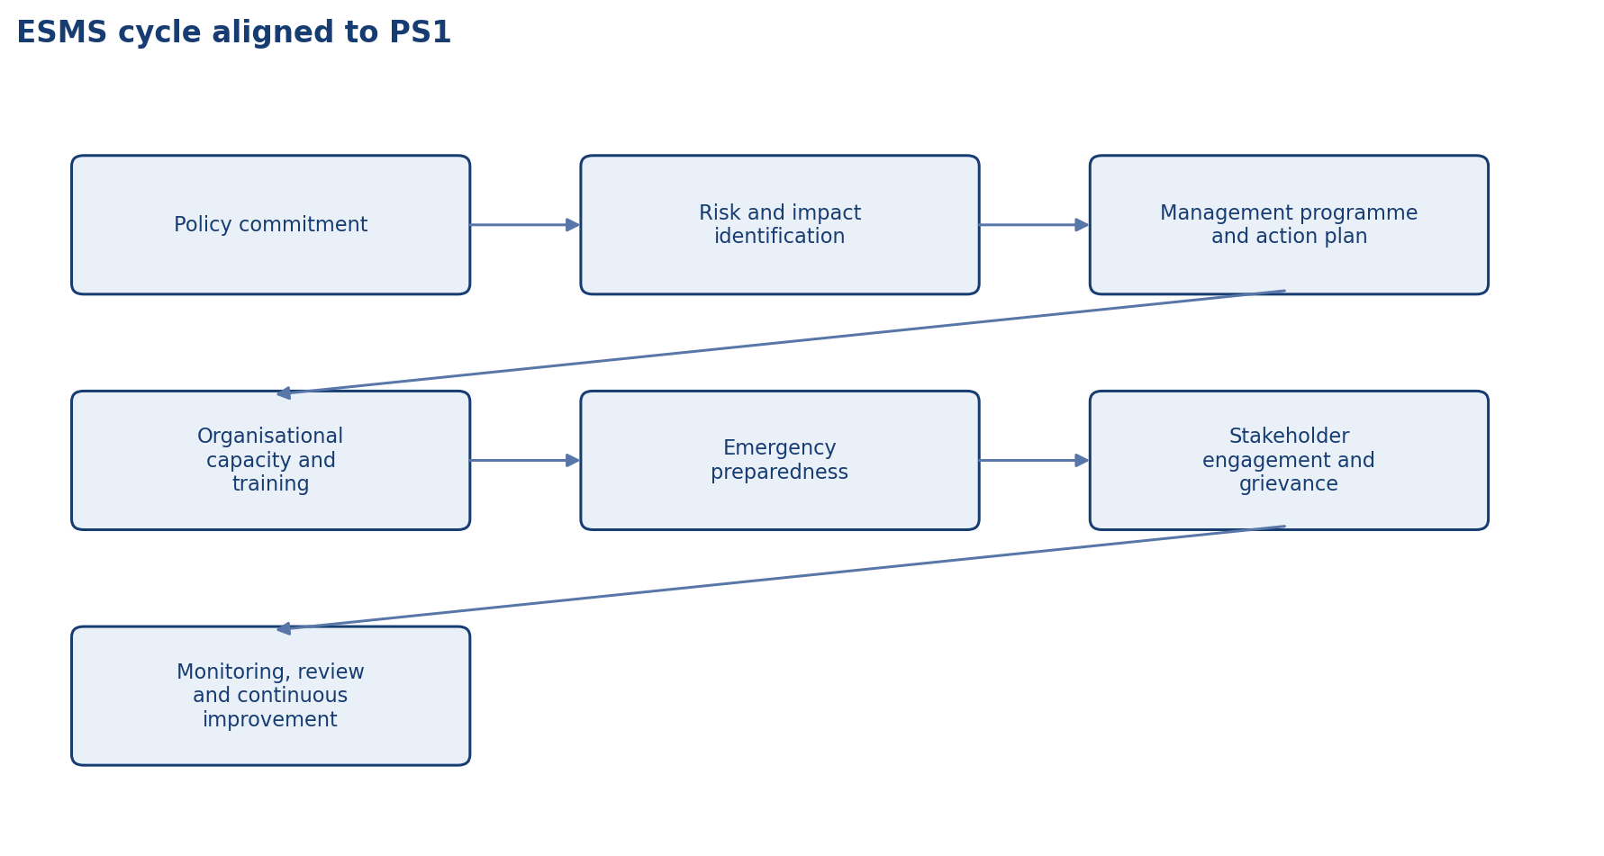
ESMS cycle aligned to PS1

Scope and application
Unless expressly excluded in writing, this document applies to NCDF Holdings Limited, controlled subsidiaries, regulated entities, managed funds, project SPVs, corporate functions, country or state programmes, and staff or contractors acting on behalf of the Group. Where a fund constitution, shareholder agreement, regulatory licence or concession agreement imposes an additional requirement, management shall reconcile the difference in favour of the stricter or more specific control.

Authority and approval
This document is issued under the authority of the NCDF Group Board and, where applicable, applies through delegated authority to the Board committees, management committees, regulated entities, fund vehicles, special purpose vehicles and controlled subsidiaries. Where local law, fund documentation or regulatory licence conditions impose stricter requirements, the stricter standard prevails.

Definitions and interpretive principles
For the purposes of this document, 'Board' means the board of the relevant NCDF entity; 'Group' means NCDF Holdings Limited together with controlled entities, programmes and managed vehicles; 'material' means any matter that could reasonably influence an investor, regulator, counterparty or stakeholder decision; and 'three lines' refers to business ownership of risk, independent oversight, and independent assurance.

Objective and scope
This ESMS sets the Group standard for identifying, assessing, mitigating, monitoring and reporting environmental and social risks and impacts associated with investments, projects, counterparties and operations. It is designed in the style of IFC Performance Standard 1 and should be read together with the additional thematic requirements relevant to labour, resource efficiency, community health and safety, land and biodiversity, Indigenous peoples where applicable, and cultural heritage.
• Provide a clear decision and control architecture that can withstand Board, auditor, regulator and investor scrutiny.
• Create consistent expectations across HoldCo, regulated entities, funds, SPVs and programmes.
• Reduce ambiguity, control bypass and key-person dependency through documented process and accountability.

Policy commitment
NCDF commits to avoid, minimise, mitigate and where necessary compensate adverse environmental and social impacts; to comply with applicable law and material contractual obligations; to apply a risk-based approach proportionate to the nature and scale of activities; and to seek outcomes consistent with international good practice. Where IFC-style benchmarks are adopted, the Group should be transparent about the scope and any deviations.

Risk categorisation and screening
All relevant transactions and projects shall undergo initial screening to determine E&S risk category, applicable standards, exclusion-list status and the likely depth of diligence. Category decisions should consider sector, geography, counterpart capability, land and labour issues, community interface, biodiversity sensitivity, security arrangements, climate exposure and reputational sensitivity.
• Control design should be proportionate to risk, but any simplification must be consciously approved rather than assumed.
• Material exceptions require documented rationale, a time-bound remediation plan and accountable owner.
• Recurring exceptions are indicators of structural weakness and should be escalated.

Assessment and action planning
Higher-risk transactions require structured E&S due diligence leading to an environmental and social action plan (ESAP), assignment of responsibilities, time-bound milestones and monitoring requirements. Action plans should be practical, verifiable and integrated into financing conditions, procurement obligations, operator contracts or post-investment value creation plans as appropriate.

IFC-style thematic modules
The ESMS should address, at a minimum, the themes corresponding to the IFC Performance Standards: PS1 assessment and management systems; PS2 labour and working conditions; PS3 resource efficiency and pollution prevention; PS4 community health, safety and security; PS5 land acquisition and involuntary resettlement where relevant; PS6 biodiversity conservation and sustainable natural resource management; PS7 Indigenous peoples where relevant under local context; and PS8 cultural heritage.

Stakeholder engagement and grievance
Affected stakeholders should have access to timely information, meaningful engagement and credible grievance mechanisms proportionate to project risk. For projects with community interface, NCDF shall require counterparties to maintain grievance channels that are accessible, documented and capable of tracking closure quality.

Monitoring and incident escalation
Management shall monitor implementation of ESAP obligations, legal compliance, serious incidents, fatalities, major pollution events, labour unrest, community disputes and other material E&S events. Serious incidents should be escalated promptly to senior management and the relevant Board or committee, with root-cause analysis and corrective action.
• Reports should distinguish current status, trend direction, forecast and required decisions.
• Management information should focus on exceptions, concentrations, overdue actions and emerging risks.
• Evidence should be retained in a manner that supports internal audit, external audit and investor diligence.

Portfolio approach and capability building
As a platform investor, NCDF should combine transaction-level due diligence with portfolio-level analysis to identify recurring E&S themes, capability gaps among investees and opportunities for targeted support. Training, templates and specialist support should be provided to teams originating and managing investments.

Roles and responsibilities

Responsibility matrix
IFC-style element | NCDF expectation
Policy | Clear E&S commitment approved by leadership.
Screening | Risk categorisation and exclusions at entry.
Due diligence | Assessment of material E&S risks and impacts.
ESAP | Time-bound management actions and responsibilities.
Monitoring | Incident escalation, periodic reporting and portfolio learning.

Operating protocol
The following minimum operating protocol shall apply unless a stricter procedure is approved for the relevant entity or transaction type.
• Use approved templates, registers and agenda structures so decisions are comparable over time and across entities.
• Maintain documented evidence of review, challenge, concurrence, approval and implementation tracking.
• Escalate exceptions, overdue actions, threshold breaches and material incidents promptly to the designated authority.
• Retain records in a controlled repository with version history, ownership and access controls.
• Provide periodic attestation or reporting to the Board or relevant committee on implementation effectiveness.

Minimum recurring deliverables
Deliverable | Typical owner | Frequency | Primary audience
Policy / charter review | Policy owner + Company Secretary | Annual | Board or committee
Management information pack | Relevant executive / control function | Quarterly | Board / committee / management forum
Training and awareness evidence | Compliance / Risk / Secretariat / HR | Annual | Board committee and internal audit
Exception and remediation log | Process owner | Monthly / quarterly | Executive management and relevant committee
Independent assurance activity | Internal Audit / external specialist | Risk-based plan | Audit & Risk Committee / Board

Implementation, review and records
Management shall maintain procedures, templates, registers and evidence necessary to implement this document in a manner capable of external review. The Company Secretary or designated policy owner shall maintain the approved master copy, revision history, approval minute references, and distribution controls for all controlled versions.

Minimum governance artefacts
Artefact | Owner | Minimum frequency | Evidence
Board or committee workplan | Company Secretary / Chair | Annual | Approved calendar and agenda pack
Policy attestation or acknowledgement | People & Culture / Compliance | Annual | Signed attestations or system logs
Training and awareness | Compliance / Risk / Secretariat | At onboarding and annually | Attendance logs and materials
Exception register | Policy owner | As needed | Documented waivers and remediation actions
Board reporting | Relevant executive owner | Quarterly | Board / committee papers

Appendix: document control summary

Control sheet
Field | Entry
Document status | Institutional policy / charter / framework
Primary audience | Board, management, regulated entities, fund governance teams and diligence stakeholders
Review trigger events | Regulatory change, major transaction, operating model change, control failure, external assurance finding or Board instruction
Related documents | Code of business conduct and ethics, disclosure policy, delegated authorities, risk governance, committee charters, ESMS, AML/KYC, procurement and compliance procedures
Retention expectation | Retain current and superseded versions in controlled corporate records repository

